Supplementary Material

Table A: POX/PenV concentration levels for single analyte and binary standards.

|  |  |
| --- | --- |
| Phenoxyacetic acid [g/l] | Penicillin V [g/l] |
| 0.3 | - |
| 0.8 | - |
| 1.65 | - |
| 2.25 | - |
| 3 | - |
| - | 1 |
| - | 5 |
| - | 10 |
| 0.3 | 1 |
| 1.65 | 1 |
| 3 | 1 |
| 0.3 | 5.5 |
| 1.65 | 5.5 |
| 3 | 5.5 |
| 0.3 | 10 |
| 1.65 | 10 |
| 3 | 10 |

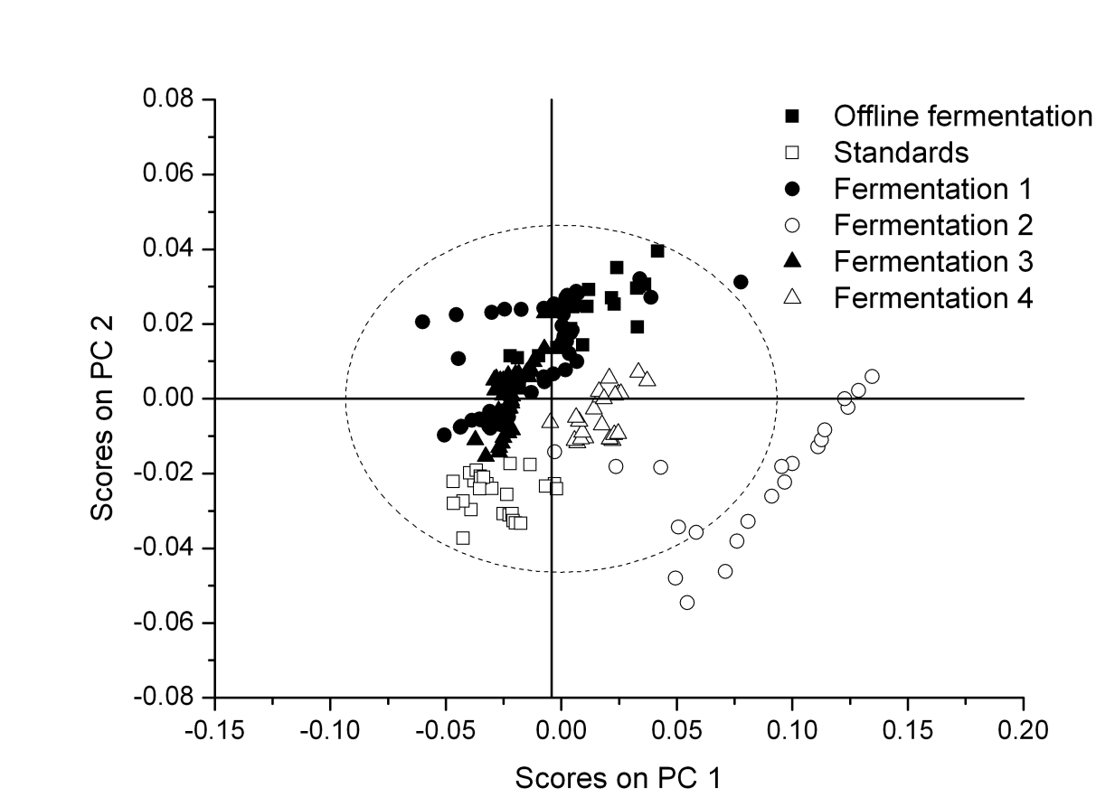

Figure B: PCA score plot of the raw data (same wavenumber region as used for the PenV PLS model, see Table 2). Similar trends can be observed for all the fermenations and the standard solutions, however the fermentation 2, during which no PenV was produced, has higher scores on PC 1 than most of the other data.

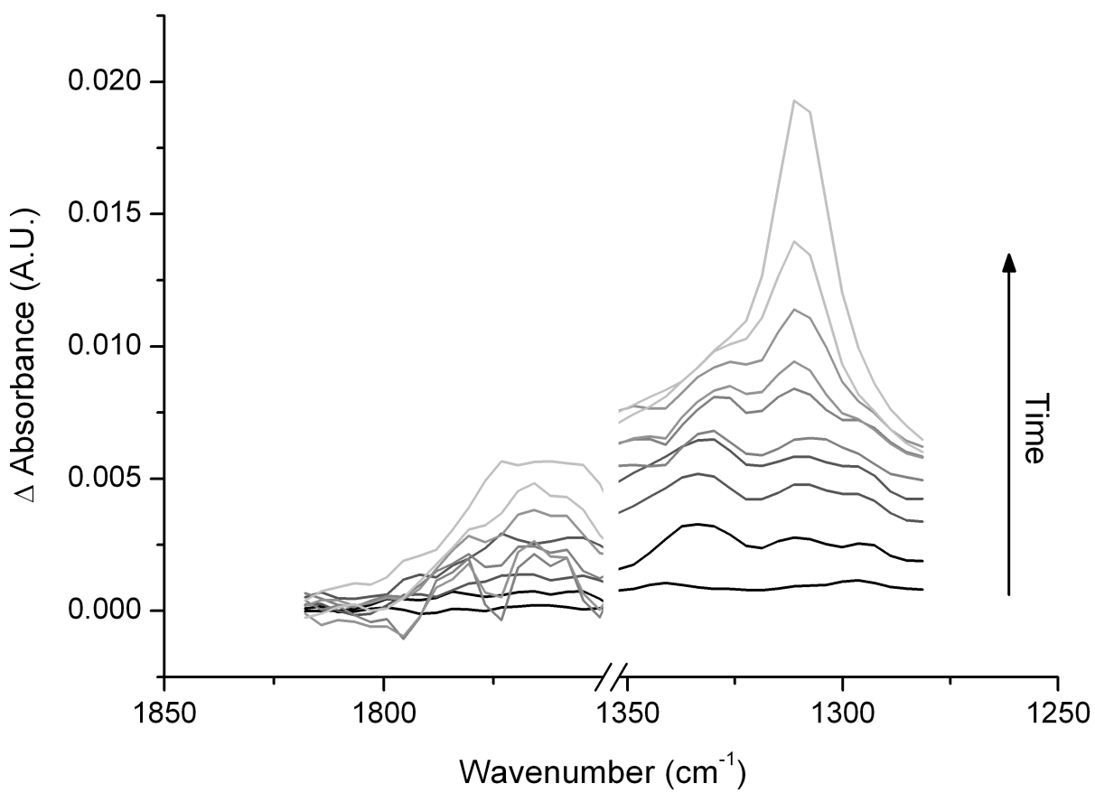

Figure C: Spectra acquired every 15 hours over the course of the fed-batch fermentation (difference spectra calculated using t=57.5h as inital spectrum, which was acquired before the POX feed was started).